# About the AVEVA Production Management ACME template

The ACME Template is a template project to show case some of the capabilities of The AVEVA Production Management, which is used to improve the performance and manage inventory of an example Coal mine in an enterprise, referred as ACME.

You will need to have AVEVA Production Management V8.1.0.698 installed to be able to restore this project.

These instructions assume that the user is familiar with AVEVA Production Management configuration.

Unzip the file called ACME Template V8.1. Once the ACME zip file has been extracted to an area of choice on the Virtual Machine, you will find the following folders and their contents within the folder ‘ACME Template V8.1’

| **Folder** | **Contents Description** |
| --- | --- |
| 0 Design | This contains the ACME Design Excel workbook (ACME _Ampla_Design workbook.xlxs). This configuration worksheet is included for reference. |
| 1 Ampla Configuration | This folder contains the XML configuration file, which will be used in step 3 below (ACME _Ampla_V8.1_YYMMDD.XML) |
| 2 Simulation Data Source | This folder contains a CSV file, which shall be used to simulate data coming from a historian data source. |
| 3 Ampla Security | This folder contains an AuthStore XML file to update the configured security settings in Ampla Studio |
| 4 Calendar Items | This folder contains a CSV containing targets to trigger downtime in Ampla |
| 5 Extra DB scrip | This folder contains the SQL query that creates the tables and stored procedures of the ACME project Extra database |
| 6 CLR SP Installation | This folder contains the scrip and dlls to register AVEVA Production Management CLR stored procedures to be used to query project data |
| 7 Shared Favorites Script | This folder contains the SQL query that creates the configured Shared Favorites for the Template |
| 8 Reports | This folder contains the SSRS solution for the ACME template reports |
| 9 Report Stored Procedures | This folder contains the two SQL stored procedures to run the reports |
| 10 MS Flow Package Webhook Example | This folder contains a zip file which has a pre-configured Microsoft Workflow as an example to send emails to outlook if specific a downtime event record is true. |

# Restore and Simulate the Project

The steps to restore and simulate the project are listed below:

1. Navigate to Ampla installation folder (default is: C:\Program Files\AVEVA\AVEVA Production Management) and open "Citect.Ampla.InstalledReferences.config" file.

* Uncomment "Citect.Ampla.Connectors.Simulation" reference.
* Save the config file

1. Open Ampla Service Manager and Create a new project " ACME _Ampla "

* Start Ampla Service

1. Open Ampla Studio and Import ACME_Ampla.xml (1 Ampla Configuration folder)
2. In Project Explorer, expand ACME_Ampla > System Configuration > Data Sources > SimulationDataSource and set Directory property to the location you have saved 'System Configuration.Data Sources.SimulationDataSource.RockyMine.csv' file (2 Simulation Data Source)

* Validate and save the project. Ignore the validation warnings.
* You may get a validation error about the password is not encrypted by this user account. To fix this error, expand ACME_Ampla > System Configuration > Integrations> Service Bus > Events >RecordChangedEventItem and enter ‘guest’ as password. This is the password for default guest account of RabbitMQ which allows Ampla to send the record change events to RabbitMQ.

1. Setup the user groups

* Create four Windows/AD groups: ACME_Admins, ACME_Supervisors, ACME_Operators, ACME_Viewers.
* Open Studio and in Project Explorer, expand ACME_Ampla > System Configuration > Users.
* Set the “Identity” property of each user group to the correct Windows/AD groups you have created in the first point.

1. Stop Ampla Service, then navigate to C\ProgramData\Citect\Ampla\Projects\ACME _Ampla folder and replace the existing 'AuthStore.xml' file with the provided file (3 Ampla Security folder). Start Ampla service.
2. In Project Explorer, expand ACME_Ampla > System Configuration.Calendar. Right click and select 'Import Calendar Values' (4 Calendar Items folder)

* Navigate to the location you have saved 'ACME _Calendar.csv' file and select it and press Open button (4 Calendar Items folder).
* In the Import Calendar Values dialog, set 'Start import at row' to 2 and press Import button. Result should be "8 Items Imported"

1. Create Extra database

* Open "Extra_Database_Script.sql" file in SSMS and execute it (5 Extra DB script).
* In Ampla Studio Project Explorer, expand ACME_Ampla > System Configuration > Data Sources > Plant2Business and check ConnectionString of all P2B integrations OleDb connections and adjust it to your SQL and Extras database

1. Save the project and stop it from the root.
2. Install Ampla CLR stored procedures on ACME_ AmplaExtras.

* Open ‘InstallScripV200806.sql’ in SQL Server Management Studio (6 CLR SP Installation folder)
* Uncomment the 3 first line and change the DatabaseName to ACME_AmplaExtras.



* Enter the path you saved the content of “6 CLR SP Installation folder” in @InstallPath.
* **Run** the query.

1. Open "ACME_SharedFavorites.sql" file in SSMS and execute it (7 Shared Favorites script).
2. Start the project from the root.
3. Start PA and check that Ampla is automatically capturing records via the simulation file.
4. You can log into PA using integrated security if the account you have used to login into Windows is a built in administrator of the machine or any user added into the groups you have created in step 5.
5. Initialize Inventory

* In Project Explorer, expand ACME_Ampla > System Configuration > Actions > Inventory.
* Right-click on InitialInventory and select Execute.
* Check Server Messages to make sure the initial balances have been added successfully.

1. Start capturing movements automatically

* Expand ACME_Ampla > System Configuration > Data Sources > Variables > Inventory.
* Select StartAutomaticMovements Stored variable and set its value to True.

# Configure SSRS and deploy template reports

The following steps are to configure SQL Server Reporting Services to host Ampla Performance template reports and run the reports from Ampla Production Analyst.

You need to have Reporting Services Native Mode Report Server and SQL Server Data Tools (SSDT) installed.

These instructions assume that the user is familiar with SSRS and SSDT.

1. If SSRS is not already configured on your machine, follow the following instructions:

* Open Report Server Configuration manager from the Start menu, enter server name and Report server instance and then press connect.
* Open Service Account tab and set the user account running the reporting services, then press Apply.

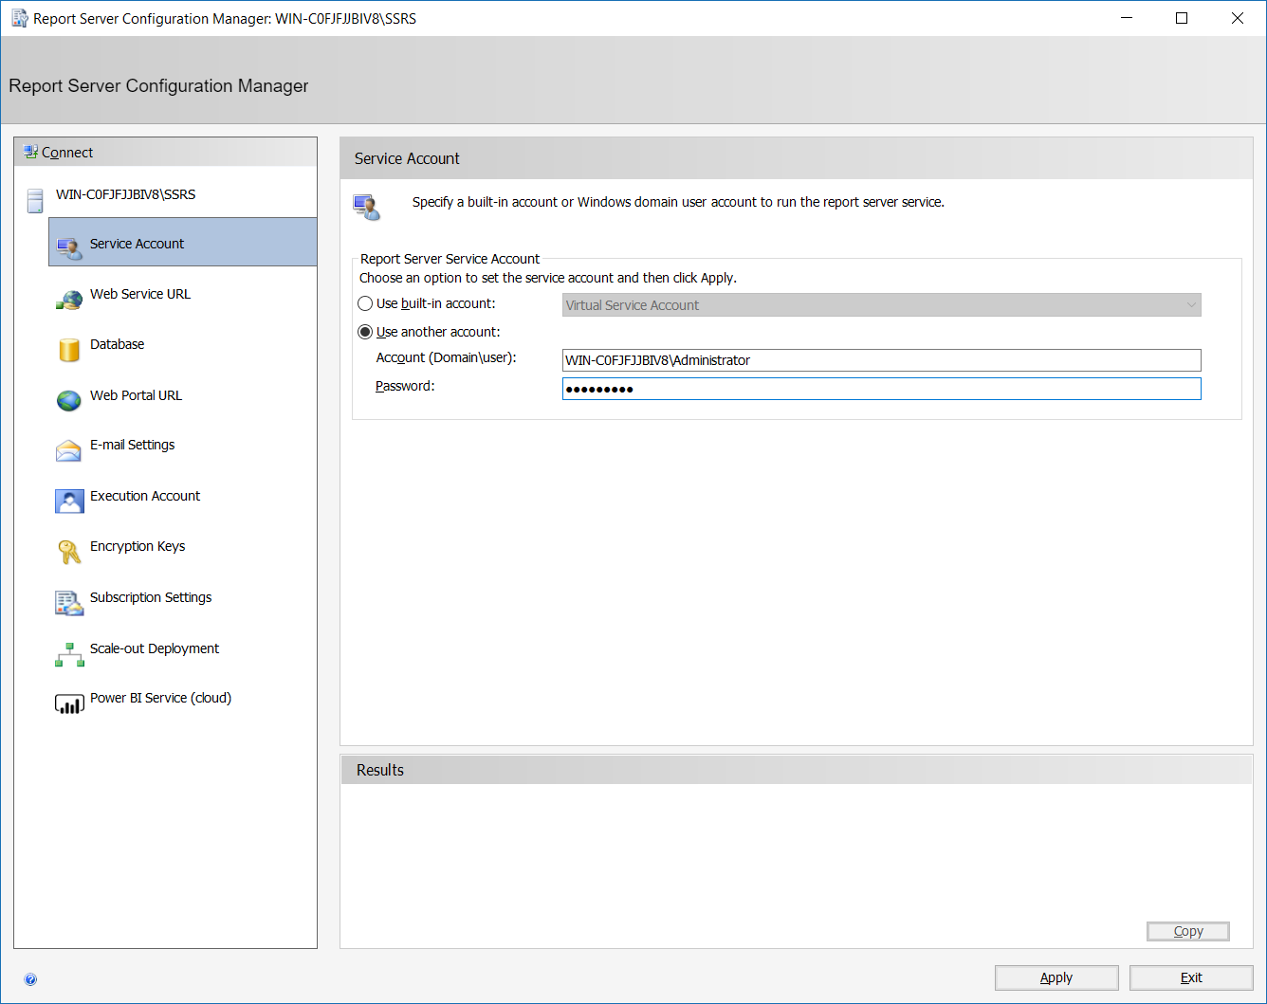

* Open Web Service URL tab and apply the default setting.
* Open Database tab and select Change Database, then Create a new report server database using the wizard without changing the default settings.
* Open Web Portal URL tab and apply the default settings.

1. Create required storedprocedures.

* Open RP_DowntimeSummary.sql (9 Report Stored Procedures) in SQL Server Management Studio and run it.
* Open RP_ShiftBalanceSummary.sql (9 Report Stored Procedures) in SQL Server Management Studio and run it.

1. Deploy the reports.

* Open ACME_Reports solution in SSDT (8 Reports folder).
* Right click on ACME_Report project and select Properties from the menu. Make sure the Deployment properties are correct and matches your SSRS configuration.

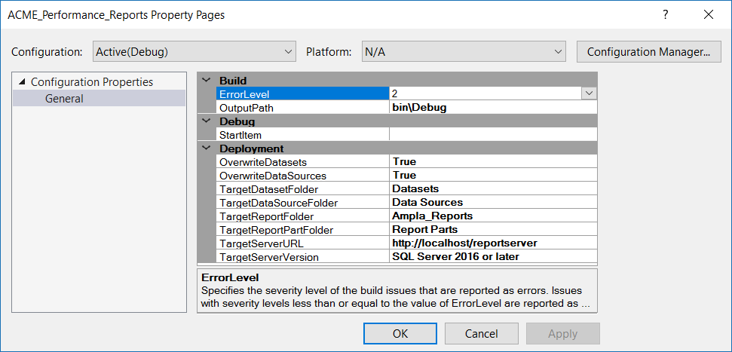

* Build the project.
* Deploy the project.

1. Open Ampla Production Analyst (PA) and access Downtime Summary and Downtime Overview reports from Reports folder in Downtime module and Shift Summary Report from all modules.

# Configure and Send Email to Outlook

The following steps are to set the project to send emails to your outlook if the ROM downtime cause is "Stockpile Low. No Coal From Mines".

Note: Your business or you will need to have the Office 360 subscription to be able to setup this integration. These instructions assume that the user is familiar with Office 365 and has used Microsoft Workflow.

1. Log in to Microsoft flow via <https://www.office.com/?auth=2&home=1> and select ‘Power Automate’ 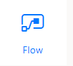

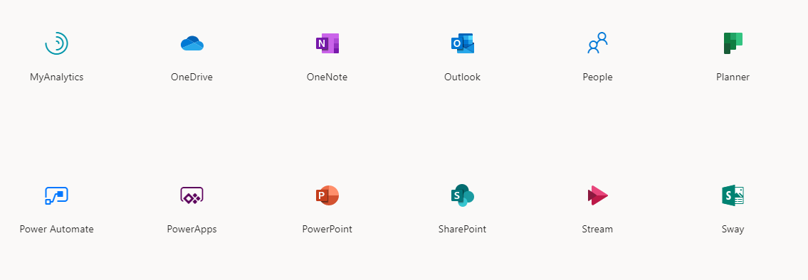

Or

1. Try the following link to take you directly to the Power Automate (Flow) page

<https://emea.flow.microsoft.com/manage/environments/Default-425a5546-5a6e-4f1b-ab62-23d91d07d893/flows>

1. If you don't already have a connection to your Microsoft 360 Outlook select Data -> Connections add a new Office 365 Outlook connector,  which will be linked to your nominated email address (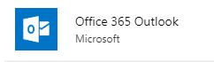)

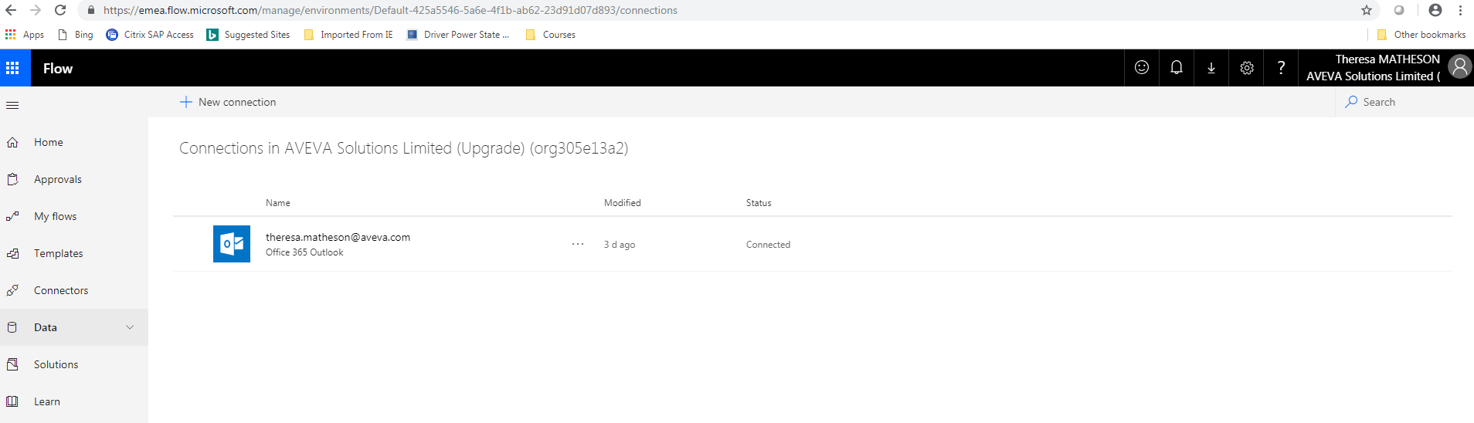

1. Go to My flows and Import the "Ampla_Webhook_Example_NoCoalInACME.zip" , located in (10 MS Flow Package Webhook Example folder)
2. After uploading the package, you will need to set the resources to be able to complete the import.

* Press Update button to change the Import setup of "Ampla Webhook - Downtime Events". Then select "Create as new".



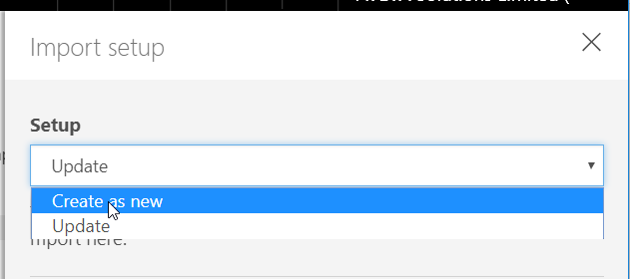

* Press Select during import to open Import Setup dialog and Change the Office 365 Outlook connection to the connection you just created (or if you already had one select it here). Then press Save.

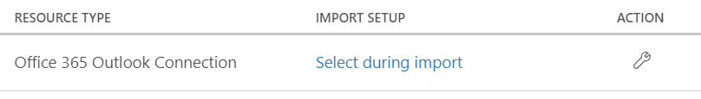

* Now the package is ready for Import. Press Import and wait until the action completed.

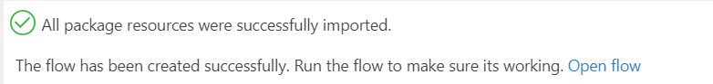

1. Now open the imported flow for edit.

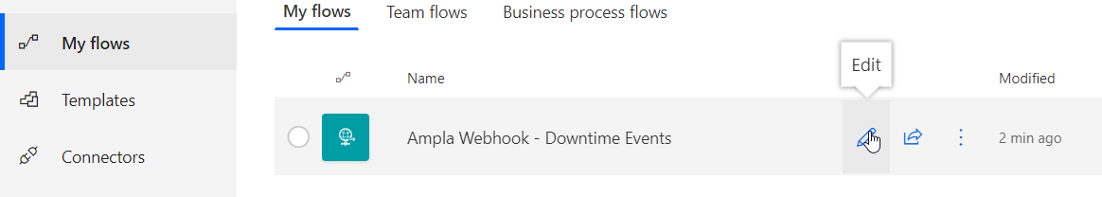

1. Now expand Condition step.

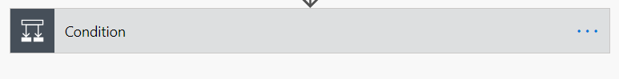

1. Click on Open "Send and email" step

* Update "To" to your email address
* Save the change

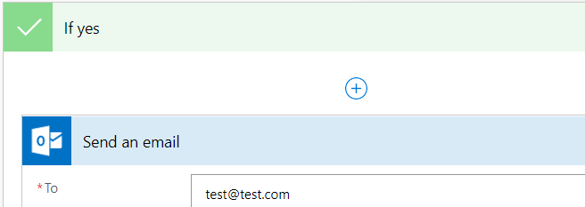

1. Open "When a HTTP request is received" step and copy the "HTTP POST URL" using the ‘Copy URL’ option 

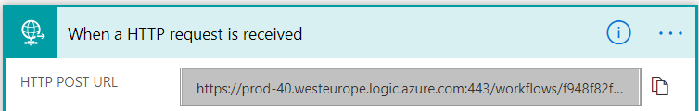

1. Then in Ampla Studio Project Explorer, expand ACME_Ampla > System Configuration > Integration > Webhooks > Downtime Event > ROM and paste "HTTP POST URL" to Url property
2. Save and start the project from the root
3. In PA navigate to ROM and complete a record setting the Cause Location as "ACME.Rocky Mine.Mining.ROM", Cause as "Stockpile Low, No Coal From Mines" and classification as "Consequential"

You should receive an email with information of this downtime

Please note, you should have access to the webhook URL from the Ampla VM Server machine for the integration to work.